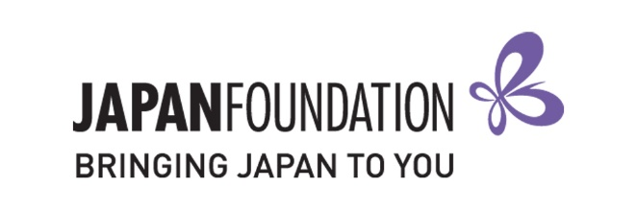
Teaching Materials Grant 2021
Special support for Natural Disasters
Form A (Application Form)

This is a restricted Word document. Please type your responses.
Details of applicant (Institution)
School name
Postal address
Suburb
State / Territory
Postcode
Principal’s name
Phone
Sector | Government Catholic Independent
Level | Primary Junior secondary Senior secondary

Details of authorised official (teacher in charge of application)
Name
Position
Work email
Mobile

Japanese program details
Number of students at the school
Number of students taking Japanese
Number of Japanese classes
Total hours of Japanese taught in a week

Has the school applied for a grant from The Japan Foundation, Sydney (JPF Sydney) in the past?
If so, provide details below (including which grants and when).

Introduce your school and its community (max. 100 words).

Describe your Japanese language education program, including its current and future goals (max. 140 words).

Explain what you intend to do with the funds provided by this grant (max. 140 words).

Application Checklist
I understand and agree to the conditions outlined in the Application Guidelines.
I have made a copy of all application documents for my own records.
I am sending the following items below by the deadline to coordinators@jpf.org.au.
- Completed Form A (Application Form)
- Material List
Note: Successful applicants will be requested to post an original copy of Form A (with original signatures) at a later date as per the requirement set by The Japan Foundation Head Office.

Authorised Official  (Teacher in charge of application) |  | School Representative  (e.g. Principal, Head of Department)
Name |  | Name
School name |  | School name
Position |  | Position
Signature |  | Signature
Date |  | Date

